N-able On-Boarding Process

1. Open N-able portal

On top of the left side panel Select Client (Arvinas).

Note:- In this SOP we are taking Arvinas Client On-Boarding Example.

2. In the left side panel select Dashboard Navigate to Device-Servers

>> Login to Jump server (ARVIT03)

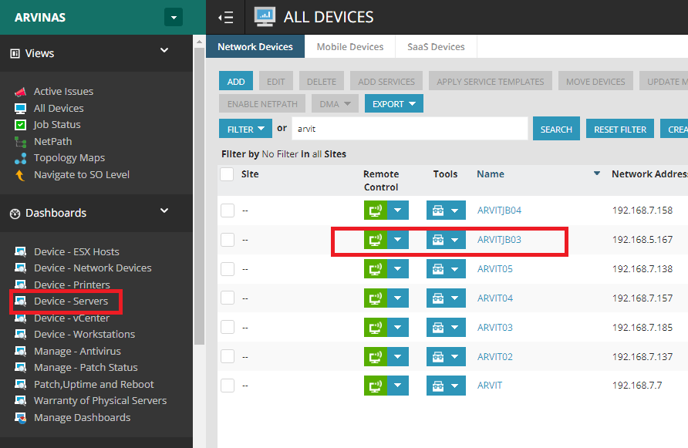

3. Open the CMD terminal run as administrator, and Ping the IP address of the server that we need to On-Board.

a. client may provide the IP address via mail

Go To CMD

>> ping IP

Ex- ping 10.5.128.49

or

b. The client may provide the Server Name

From the Jump server open Google Chrome browser 🡪 open V-Center 🡪 Login V-center search Device name given by the client.

We can see the IP address of the server, Ping IP address from the jump server CMD  
  
  
4. We may get the issue that unable to ping the IP, Request timed out. The reason is due to the firewall on the server which we want to ping. The firewall may not allow IPV4 and IPV6 ping

🡪If we get a request timed out Then follow the below process.

>>From the Jump server take RDP and connect to a new server which we need to Onboard (10.5.128.49).  
>> Search Windows Defender Firewall🡪 Advanced Settings🡪 Inbound Rules

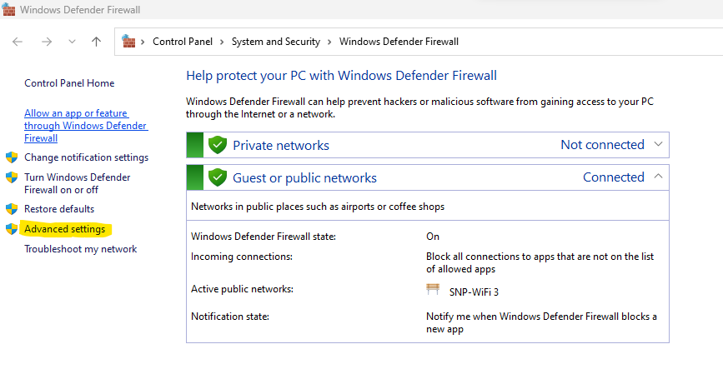

🡪select file and printer sharing (Echo request-ICMpv4-In and ICMpv6) >> Click on Enabled YES

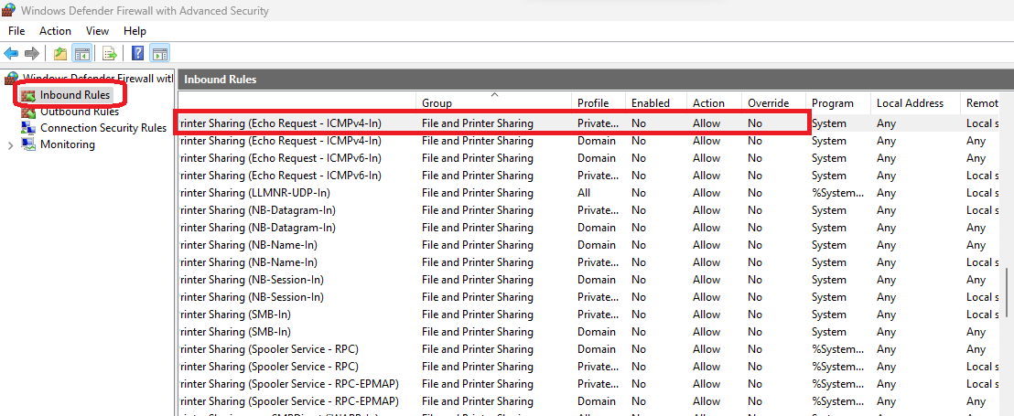

5. After this again check Ping 10.5.128.49

6. After Completion of the above process follow the below steps to On-board the Machine into the N-able portal.

>> Navigate to Configurations 🡪 Asset Discovery🡪 Discovery Job🡪 Click on Add

7. Provide Details based on client requirements such as device name ( The name for the device) device IP.

Note: Device IP should be the IP-last pointer of the IP, so that it will create one IP for the server or else it may take IP range of 256.

Ex: 10.5.128.49-49  
  >>We can select prob as Jump server name

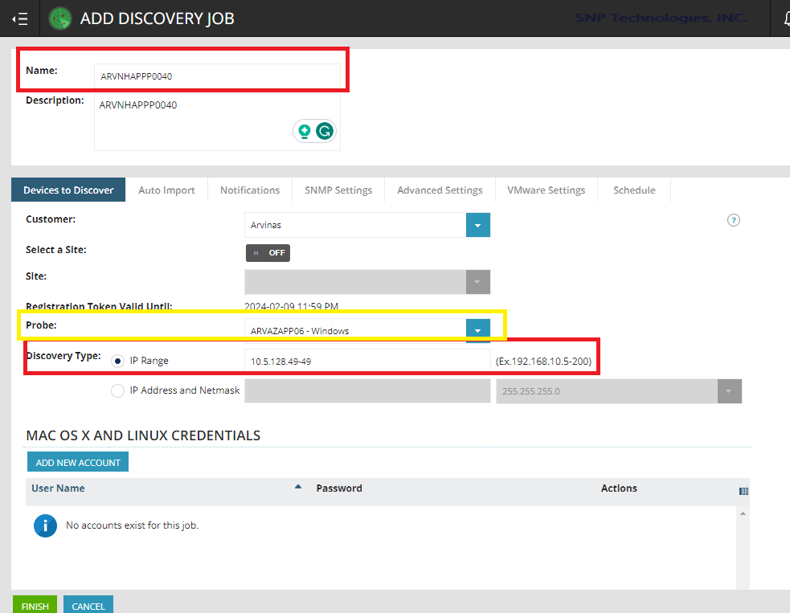

* Go to the Auto import option and deselect all

>> Click on Finish.

8. After the above process the newly added server will be discovered in **Discovered Assets** option under the **configuration**.

>> Click on that Device 🡪 Set License Mode🡪 Professional  
>> Click on Import   
 >> **Successfully onboard the Machine in N-able**

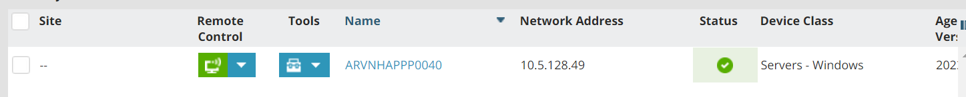

NEXT:- After the above process the server will be added to the N-able portal, we can manage the server configuration and monitor alerts on the server, etc.  
To Extend more operations on the server such as applying Azure policies, and governance, and enable more security (cloud defender) we can onboard the server to Azure.

To onboard the server to Azure we use Azure ARC.  
  
Ref document—” Azure Arc”